Nytt aktsomhetskart for flom: brukerguide & metodebeskrivelse

Brukerguide
The new flomaktsomhetskart i built in a modular manner, iterable through a jupyter notebook script that is provided in the flomaktsomhetskart github. New iterations are published when developed and code modularity is emphasised, with different applicable modules being easily added and removed from the primary script functionality that is based on the old model (REF: aktsomhetskart for flom metodebeskrivelse). To use the new model, there are several basic requirements which are documented below as a series of instructions.
- Download the current newest version of the aktsomhetskart script from its github page: https://github.com/ThobNVE/Nytt_aktsomhetskart_for_flom.
- Set-up anaconda on your machine using firmaportal to download and install Anaconda Navigator, or if on a non-managed machine download from https://www.anaconda.com and follow the setup instructions. An alternative is to use Command Prompt or PowerShell. All setup modes are documented under “Installing Anaconda Distribution” on the Anaconda website.
- Using your newly set up Anaconda distribution, install the environment that has come with the latest version of the flomaktsomhetskart script. This should be in the folder “envs” within the download. This can be done either using import in Anaconda Navigator, or by opening Anaconda powershell and navigating to your saved environment directory by typing:
cd path/to/directory
Then typing:
$$\text{conda}\text{ env create -f }\text{PythonGIS.yml}$$

Let this run, and your environment should be set up. To activate and use the environment afterwards via PowerShell or Command Line, you can type:
$$\text{conda}\text{ activate }\text{PythonGIS}$$

- Otherwise, it should now be possible to use the script via Microsoft VSCode or other python clients directly, by selecting PythonGIS as your operating kernel.

- Now, you must set up your file system as specified in the “Nytt aktsomhetskart for flom” github. You are required to have the following system:
/Hovedmappe/ | /FLOWACC/ | For “flow accumulation”-filer
 | /BURNED/ | For DTM innbrent med elvdata som .tif-filer.
 | /ELV/ | For DTM-basert elvenettverksdata.
 | /FLD/ | For produsert flom-lagene.
 | /RNET/ | For invertert elvenettverk for innbrenning.
 | /OUT/ | For DTM som er skalert til en valgt oppløsning.
 | /RAW/ | For “rå” 1 m DTM data lastet ned fra Geonorge API.
 | /FDIR/ | For strømretningsdata.
 | /Scripts/ | For scriptene, bade .ipynb og .py.
 | /envs/ | For Python-miljø .yml filer (ikke nødvendig)

- From here, it is possible to run the script. Be aware that if you do not have the associated DTM already processed, this can take an hour or longer depending on your connection speed for the first iteration. Running the script without editing start-up parameters will produce an output for the Gaula vassdraget (122.Z) in the Trondheim area of Norway.
- Within the script, the cell “DEFINE VARIABLES” allows for modification of the output. The primary variable for non-developers to use is “vassdrag_nr” which defines the catchment region to be mapped. A query can be made in “Søk her for vassdraget ditt” below, allowing for a specific region to be identified by name, returning the metadata including vassdrag_nr.
- Once parameters are set, clicking on “Run all >>”, should set the PythonGIS kernel running, and will produce a series of outputs.
- The key outputs that are relevant for the aktsomhetskart are as follows:
/FLD/ | AKT_TOT_VD_Gaula_STO6_RB2_R5m.tif
 | AKT_TOT_VD_Gaula_STO6_RB2_R5m.gpkg
 | AKT_ELVIS_VD_Gaula_STO6_RB2_R5m.tif
 | AKT_ELVIS_VD_Gaula_STO6_RB2_R5m.gpkg
 | AKT_DTM_VD_Gaula_STO6_RB2_R5m.tif
 | AKT_DTM_VD_Gaula_STO6_RB2_R5m.gpkg
 | AKT_DYBDE_VD_Gaula_STO6_RB2_R5m.tif
 | AKT_VSS_VD_Gaula_STO6_RB2_R5m.tif
/ELV/ | SORD_VD_Gaula_RB2_R5m.tif

Anatomi av utgangsnavner
Each output filename indicates the exact content of the output data. Figure 1 below shows the general contents of an end-state flood output filename.
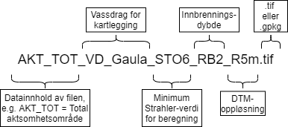
Figure 1. anatomy of an output file from this script, specifically this uses an end-product “total flooding area” dataset as an example.

Metodebeskrivelsen

Grunn for modellen & modell basis

Generell oversikt av modellen

Importerte data
This script operates using several imported datasets, no manually downloaded data is required. Both datasets are retrieved from national map data databases, including the Norwegian “Høydedata” database, from which 1 m elevation data is retrieved, and “FKB_vann”, from which river and catchment data is retrieved. Høydedata is Norway’s national elevation data portal, including national-scale and local projects of elevation data mapping ranging from sub-1m scales to 50 m and higher scales across the country. Mainland Norway has a full 1-m resolution gridded elevation dataset, based on point-cloud data based on the methodology from FKB-Laser 3.0 (REF FKB-Laser: https://register.geonorge.no/register/versjoner/produktspesifikasjoner/kartverket/fkb-laser). FKB-vann (REF FKB-vann https://register.geonorge.no/register/versjoner/produktspesifikasjoner/geovekst/fkb-vann) is a national-scale dataset which covers the extent of surface hydrology within Norway, built through compiling all of Norway’s pre-existing digitalised hydrological data.

Oppsetting av modellen og data

DTM reskalering
For this methodology, we import the DTM-1 national dataset, and then scale this to a selected resolution. 1m data required several hours of processing time per catchment area, and as such we opt for a lower resolution, particularly as the aktsomhetskart is designed as a coarse visual model rather than a detailed dataset. The 1 m dataset is used due to the higher data quality than that present in the 10 m dataset which is used in the old flomaktsomhetskart model. The resampling is carried out through an additional script “resampletif.py” which is based on rasterio functionality. The default resampling method used in this script is rasterio’s “resample.average” (https://rasterio.readthedocs.io/en/stable/topics/resampling.html), where the average value of all input cells is used for resampling (Figure 2).
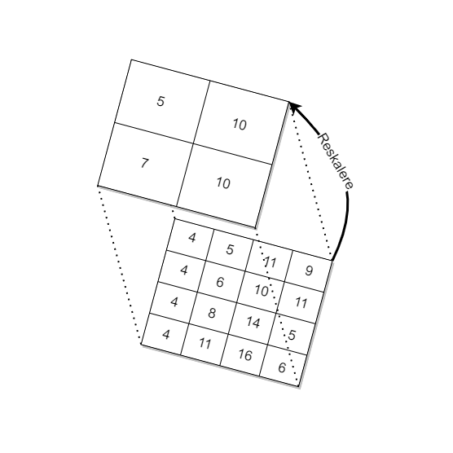
Figure 2. Demonstration of the rescaling methodology, each group of pixels is averaged to a larger pixel. If this were to represent 1x1 m scale original pixels, then this would be rescaling to 2x2m pixels.

Innbrenning av elvene
The 1 m DTM, at its basis, is relatively effective for flow accumulation calculation on its own, however there can often be small issues in the dataset caused by irregularities in point cloud data, resampling and poor interpolation during data production. Further, whilst the 1 m DTM data for Norway has bridges, culverts and other related watercourse features removed (in general), there are likely some features which are missed or otherwise, and remnant structures produced in the conversion from DOM to DTM. As such, it is good practice to “burn in” known existing rivers into the DTM. The original flomaktsomhetskart used a burning depth of 50 metres, particularly to address such things as high bridges, however this is unnecessary with the quality of the 1 m DTM model. For this script, values ranging between 0 metres (low occupation areas) through to 10 metres are required, with a default value for 5 m resolution being set at 2m burning depth. This essentially makes river centrelines “deeper” within the elevation model, and thus when flow accumulation is calculated, flow will preferentially follow the burned in rivers from the ELVIS river network dataset from FKB-vann.
Due to the high resolution of our input data, there are often small discrepancies in the river, particularly in wide, flat areas, where the water surface has been derived from a laser-based point cloud that detects surface waves. We fix this in two ways, first here, where we widen the burned-in river by 1 pixel to either side (buffer in the script), allowing for a wider burned channel, and secondly through removing vertical noise as described in the following section.
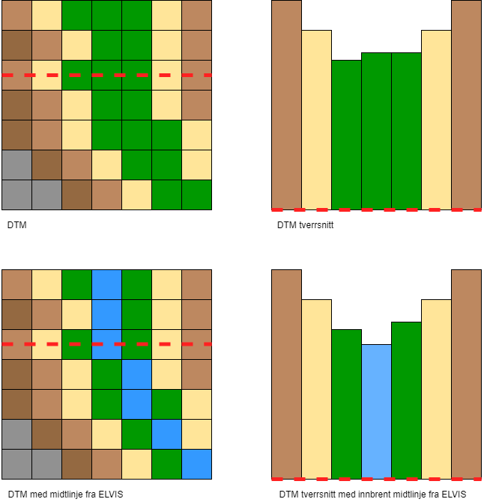
Figure 3. Demonstration of river burn-in from the DTM data, the pixel buffer is not represented here, as this is an approximation of the burn-in process.

Fjerning av vertical støy
After burning of rivers, sinks and depressions are filled to avoid “pooling” of water within the DTM. This process checks the DTM for areas where flow accumulates into single-pixels or areas distant from flow outlets and fills them to the same level as neighbouring cells. This allows for flow accumulation to orient downstream throughout the whole vassdrag system. After sink filling, during testing we found that small areas of each river channel were blocked due to sub-centimetre scale blockages in the channel, likely a result of the high-detail DTM capturing an uneven water surface and boulders in the channel. This was resolved by inverting the DTM and iterating a “full sinks” operation on the high points, essentially smoothing out these points to match with their neighbours. This was further alleviated by rounding the DTM to 2 decimal places, to avoid any other obstacles of 0.0001 metres within the channel or elsewhere causing obstructions to the main flow of water.
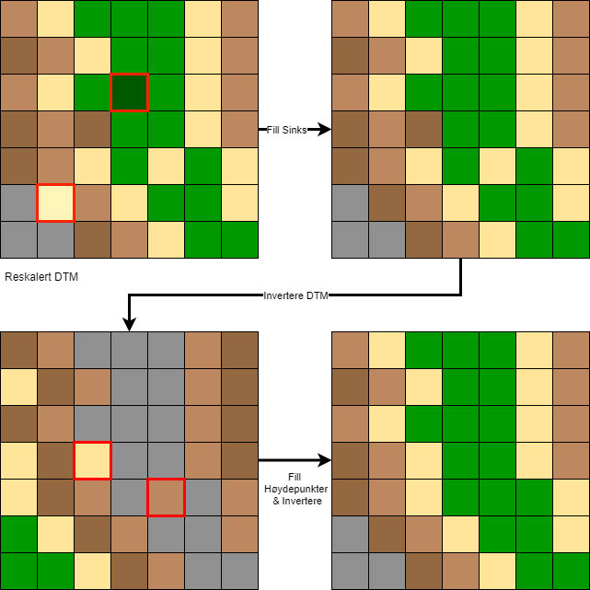
Figure 4. Demonstration of the “fill sinks” and “fill high-points” methodology used, where areas which can obstruct or collect flow direction & accumulation are detected and filled to be in keeping with the rest of the DTM.

Strømberegning og simulasjon
Streams and flooding within the new model are calculated using the python module “pyflwdir” (REF pyflwdir https://github.com/Deltares/pyflwdir 10.5281/zenodo.14889722). Pyflwdir is an open-source toolbox for working with hydrological and topographical methods in Python, and is powered by numba for rapid processing (https://numba.pydata.org/). It is commonly used contemporary to this model’s production in flood mapping for other countries (REF Diehl etc.), and provides several out-of-the-box tools for processing.

Strømningsretning
For flow direction mapping, we use pyflwdir to produce its core product, a “FlwdirRaster” object. This is essentially a raster of flow directions calculated from a DTM using a specified model of flow direction. For the aktsomhetskart for flom, we use the d8 methodology, meaning water can flow out of a cell to any of its 8 neighbours if the neighbours are lower in elevation than the current pixel. Values of flow direction are produced as “flow direction indices”, and with the d8 method in pyflwdir, the lowest neighbouring cell is selected for flow, rather than all lower neighbours. The output from this is both a d8 flow direction raster which can be exported, but also the core dataset for further processing.
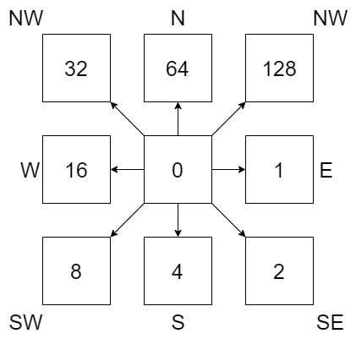
Figure 5. Diagram of possible flow direction assignment to pixels within the d8 flow direction model. Values are assigned based on greatest gradient between each neighbouring pixel, and the output resembles an “aspect” raster.

Strømningsakkumulering
Flow accumulation is calculated using the flw.upstream_area functionality from pyflwdir. This takes the flow direction raster object (flw), and calculates upstream area in a defined unit, for which we use km² to simplify flood height calculations. Flow accumulation is thus used as a core component of the maximum flood height calculation. Minimum stream order is derived using the term np.where(uparea > upa_min, streamorder, 0).

DTM-avledet elvenettet og strømrekkefølge
At this point, we also calculate stream order using flw.stream_order, for use later to define the minimum stream order for flood calculations, based on having a minimum accumulation area of above 0.5 km². Further, we produce a basic stream network, by converting the stream order raster into a binarised raster and streams geopackage vector layer for visualisation purposes using a where query, and flw.streams. The streams vector layer makes use of the calculated minimum stream order for determining the minimum stream order to display in the stream network dataset. Minimum stream order is also used for flood calculations, as stream orders below this value are not included in flood or HAND related calculations.

Beregning av oversvømt areal
In the old methodology, flooded areas are calculated using maximum inundation depth, and then simulated outwards at 90 degrees to the river as cross sections. This new methodology makes use of the HAND (height above nearest drainage) calculation to connect pixels with their nearest river pixel, based on the flow direction dataset. We further weight this data in our process through using both river order based weights, and distance-based weights in order to balance the influence each river has on water levels in a given area.

Beregning av maksimal vannstandsstigning: basert på den gamle metoden
Maximum flood inundation depth is calculated through an estimated set of calculations based on an investigation into growth curves of floods at several instrumented catchments across Norway. This methodology was originally developed in 2016, and at present we use the exact methodology developed in the prior model. This also mirrors approaches taken across Europe, including in the UK’s flood model. The calculations used are as follows:
$$Where A=0-1{km}^{2} :dVst\left(m\right)=2$$
$$Where A=1-500{km}^{2} :dVst\left(m\right)=0,965*\ln\left(A\right)+2$$
$$Where A>500{km}^{2} :dVst\left(m\right)=8$$
Where A = upstream area in km² and dVst is maximum inundation depth at the river. The values returned by these equations are conservative estimates of flood inundation, but are based in measured data from Norwegian catchments across the country. However, there are several unclear uncertainties with these data, and as such future adaptations should occur.

Implementering av HAND-modellen HAND
While the old model makes use of cross profiles that are 90 degrees to the river, we use a geomorphologically grounded approach for calculating flood inundation. The HAND model uses flow direction indices to connect upstream pixels to their nearest drainage (stream) pixel, and then normalises the elevation data to the river, so all values are given as “height above the nearest drainage” (HAND). While simple, this model provides an elegant means of connecting flood inundation more directly to its most relevant stream pixel, and thus we are able to calculate a more geomorphologically connected version of flood inundation versus prior attempts with cross-profile methodologies (Figure 6). Once HAND is calculated, areas where the inundation depth of a parent river pixel are higher than the connected local pixels, we flag the given cell as “flooded” (figure 7). We calculate a simple depth estimation for flooding using our inundation depth and the HAND model, where we subtract the HAND model from our inundation depth. In doing so we produce a result of 0-8m inundation depth across the simulated flood area.

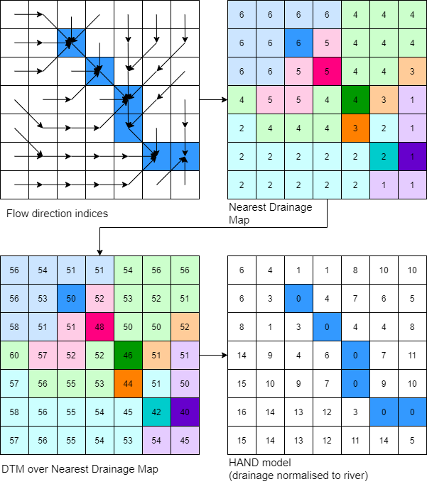
Figure 6. Diagram of HAND methodology with a simple river dataset. First, flow direction is calculated and converted into a nearest drainage map following flow direction indices. Then, a DTM is overlaid over the nearest drainage dataset and normalised, subtracting river elevations from their connected pixels. These pixels then become the “drainage points” for each subsection of areas, producing a map of elevation values above their most associated river point.

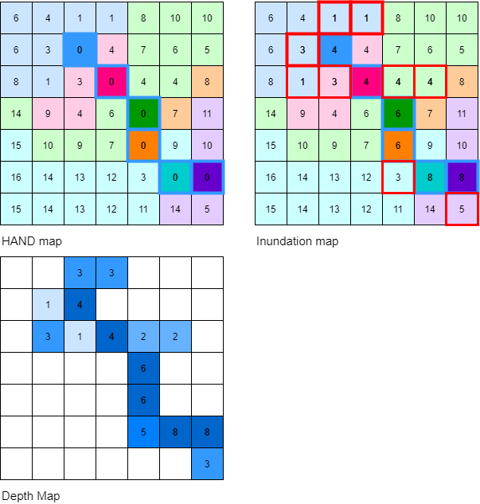
Figure 7. Representation of how HAND and flood inundation are compared to produce an “oversvømt areal” map, coupled with a depth map.

Datavekting: håndtering av problemer med små sideelever
Within this process, there arises several issues with small side catchments interfering with the flooding capability of the main river, particularly within the main floodplain. In order to rectify these issues, we weight our data, ensuring that main rivers dominate smaller rivers based on stream order, and pixels that are further from a given river are given less precedence over the data. Furthermore, we separate flood inundation per stream order, as a means of ensuring that main rivers are more influential to flooding in areas where small side rivers exist. After calculation, these layers are recombined, and maximum flood value is used, as there are several regions where small (order 7 or smaller) rivers overlap with the catchment of the main river. While problems still arise on account of differential small catchment sizes, this allows for main rivers to dominate more clearly within their flood plains, whilst small rivers are still influential in their own catchments.

Buffer-produksjon med hensyn til lov
After depth calculations, to be in keeping with Norwegian legal requirements, we buffer all streams and lakes with a 20 m buffer on all sides. Building is restricted within 20 m of a known water course, and as such, this buffer represents this area. Primarily these areas are more prone to flash-flooding, and as such depth is not readily calculable due to the lack of simulated flooding from the inundation model used here.

